# 附件1

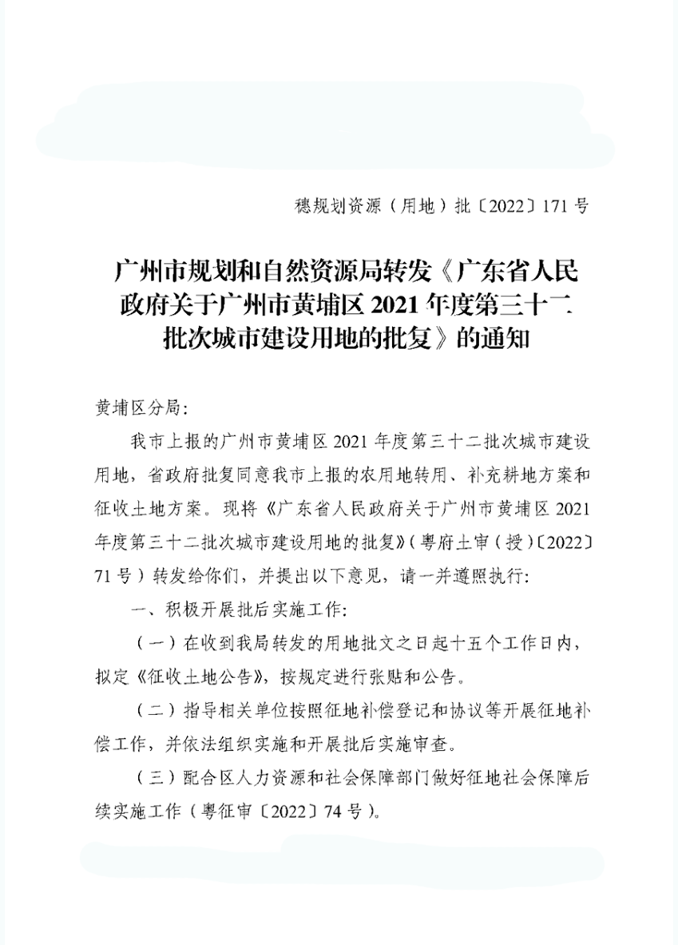

# 2

# 3

# 4