附件1

# 1

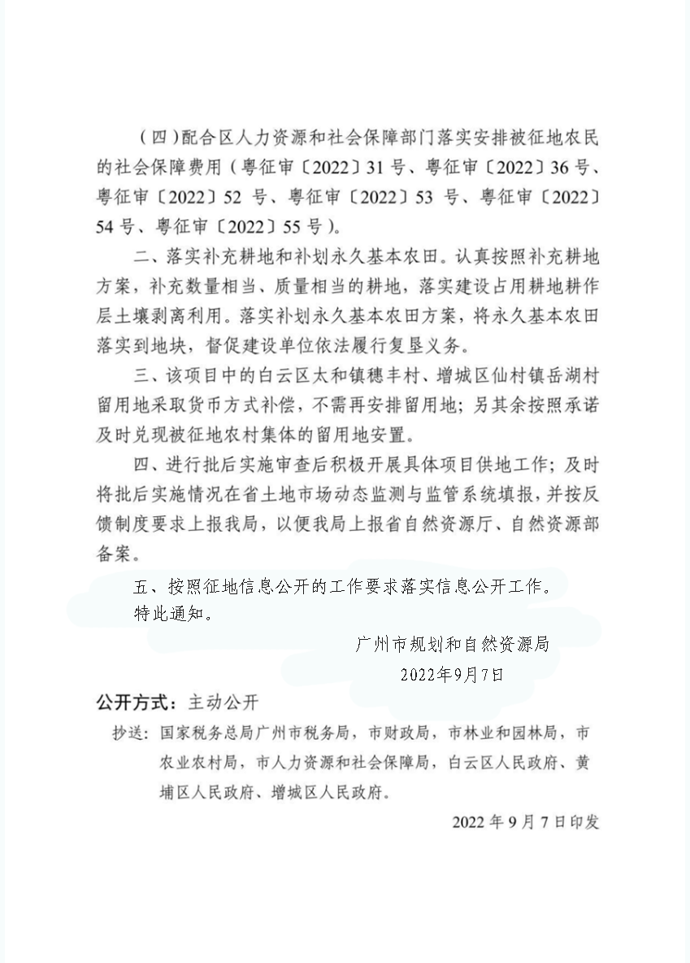

# 3

# 4